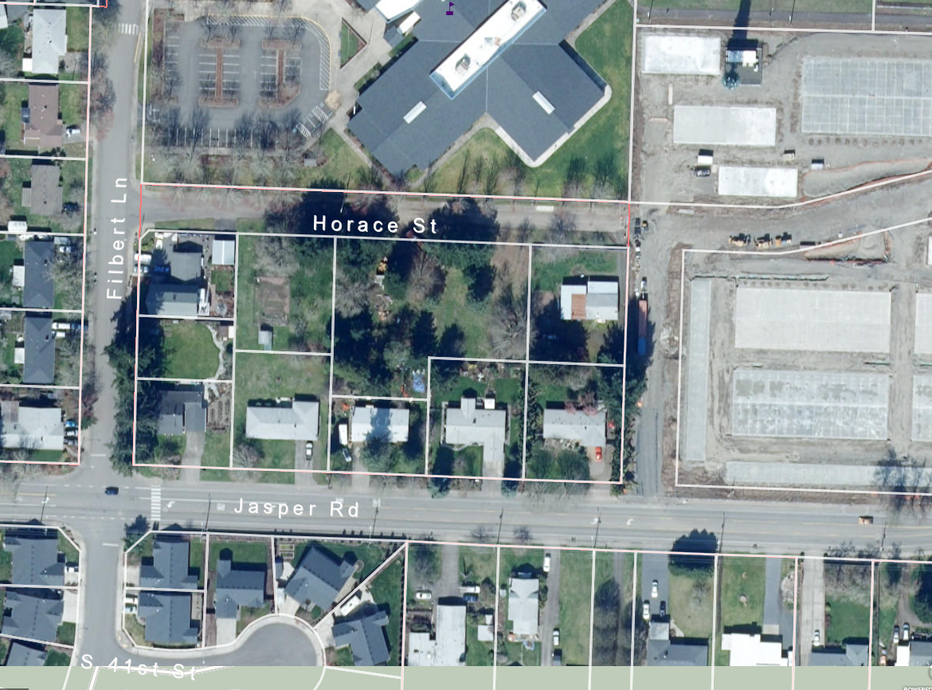

**SITE**

VICINITY MAP

811-21-000196-TYP3 Discretionary Use

18-02-05-23 TL 202 & 204

Horace Street

Bruce Wiechert Custom Homes